Franklin COMP 294

Practicum Project Weekly Status Report

Name: Christa Fox

Course Number: COMP294-R1WW (F17)

Project Name: F17Gradebook

Week Number: 10

Progress for the week

Resolved tickets 38, 40, 41, 50, 52, 53, 62, 63, and 64

* Ticket 38: Implement Activity Attendance:
  + Implemented the java code to ping the DB for the dateOfAbsence and amount of absences assigned to that course+userID
  + I did implement this in java, xml, and PHP My idea for this view is that the boxes that say text view were editable dates and you could add with the plus button and delete the absence date if the absence was listed in error.  
    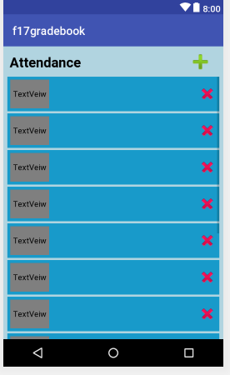
  + For the scope of the app we opted to keep it in the courses landing page because it was more user friendly, rather than clicking on attendance.
  + I also made changes to make the style match the other pages.
* Ticket 40: Implement Activity Contacts:
  + Contacts had loads in the contact name, phone number, and email. There is a way to delete and add, but it wasn’t fully implemented.
  + I thought this was going to be a universal contact list that would sync with your phone contacts, but we decided that we only wanted to link other students while they were in your class.  
      
    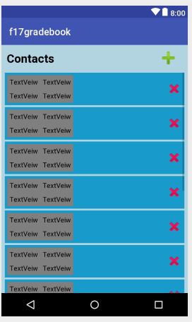
* Ticket 41: Implement Activity Resources:
  + The scope of this changed from what I initially wanted to achieve a couple of weeks ago. I wanted to host assignment files, but we changed this to a list of websites instead. They will list a name for the resource and the URL. They match the other pages. This was also set up to add and delete resource pages, but we narrowed the scope to only pull from the database—a student view.
  + The contact button will be removed, since it will no longer link from the resources page.
* Ticket 50: Database Implementation Attendance
  + Created PHP file and used json to pull data from the db with this.
* Ticket 52: Database Implementation Contacts
  + Created PHP file and used json to pull data from the db with this.
* Ticket 53: Database Implementation
  + Created PHP file and used json to pull data from the db with this.
* Ticket 62: Activity Transitions: Attendance
  + Clicked throughout the app during our Google Hangouts Meet on November 12. Also tested that intents were working and the app would not crash on our activity
* Ticket 63: Activity Transitions: Contacts
  + Clicked throughout the app during our Google Hangouts Meet on November 12. Also tested that intents were working and the app would not crash on our activity
* Ticket 64: Activity Transitions: Resources
  + Clicked throughout the app during our Google Hangouts Meet on November 12. Also tested that intents were working and the app would not crash on our activity

Problems Solved

* Refactored attendance with a new class and layout to make it work. AttendanceListAdapter.java, attendance_list_item.xml
* Changed the XMLs I had written for the layouts for attendance, contacts, and resources to match the style of the assignment.xml since it had color and text styles—to create a more unified product.
* Getting the different file types to communicate with each other was trial and error and some research. Justin and Lisa were especially helpful about troubleshooting and explaining reasons for having certain code.

Communication

* Tickets resolved on Unfuddle
* Pulled from the repository
* Committed changes
* Used text/email/google hangouts
* Google hangouts messages
* Google Hangouts meeting on November 7th and 12th
* Attended the presentation

Goals for next week

* Create a final testing log
* Complete a report
* Assist Lisa with the final report—create descriptions for end-users on how to use the activities in the application that I was responsible for (resources and contacts).